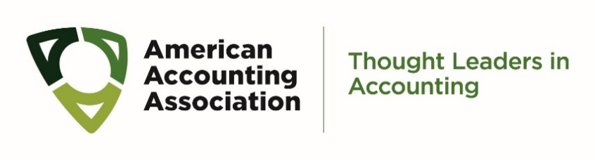
Call for Nominations
2021-2024 AAA International Council Member-At-Large

Nomination for 2021-2024 International Council Member-At-Large
(The Board of Directors will make the appointment at the March 2019 Board of Directors meeting.)

Nominator’s Full Name and Affiliation

Nominee’s Full Name

Nominee’s Affiliation

I confirm that I have contacted the nominee and that s/he is willing to be nominated (Required) ☐ Yes ☐ No

Please share up to five reasons for your nomination.

Options for Submitting This Form

Email:
- Save the completed form to your desktop and attach it to an email to nancy@aaahq.org, or
- Print the completed form, scan it to your computer, and attach it to an email to nancy@aaahq.org

Fax: 941-923-4093

Submission deadline is Noon (Eastern) on Friday, March 5, 2021

American Accounting Association| 9009 Town Center Parkway | Lakewood Ranch, FL 34202 | 941-921-7747

